Hello David,

The trophy is truly magnificent, Barrow Farm Riding & Carriage Driving for the Disabled Association (RDA) are delighted and we look forward to being involved in presenting it next year to the worthy rider. Please pass on our immense gratitude to the President and lovely members of SWF Rotary who have supported Charlotte and Barrow Farm RDA for a number of years.

We wish you all a Happy and Healthy Christmas.

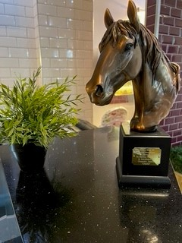

Kindest regards
Andrea & Tom Jessop

