SWF Rotary is Pleased to support Barrow Farm in their Hour of Need
SWF Rotary once again has been able to support an organisation which has been called upon in difficult times to provide very real support for those in the community who have greater need than many of us. Despite the lockdown being in force the need for others who give their expertise where it is required in the community is always there. The attached letter from Barrow Farm demonstrates the appreciation at this time for them to have received help.
Your Rotary also needs Community Help. This means All of our readers.
Barrow Farm Letter:-
Dear Ken Your cheque has now arrived and we would like to thank the Rotary Club of South Woodham Ferrers very much for their much appreciated donation. It was very kind of you to think of us at this particularly difficult time. We really are very grateful for your support.
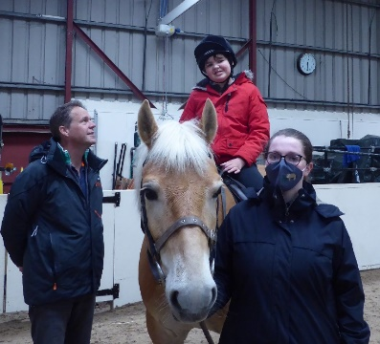
As you would imagine this has been a challenging time for us - we had to close during all the lockdowns but we are delighted to be back open now with almost all of our non-special school children and adult riders back riding. As social distancing restrictions have lifted, we have been able to get more riders back including those who need more support. We hope our special schools will be able to return in the autumn term. The ponies are fit and healthy thanks to the hard work of the staff throughout the last lockdown so they are keen to be back helping as many riders and drivers as they can!!
Life and finances have been challenging for us over the last year so your support to us is incredibly important and we very much appreciate it. Once things have quietened down perhaps some of your members would like to visit and see what we do?
With sincere thanks and best wishes,
Karen Lehnerice Chairman, Trustees karen@barrowfarmrda.org.uk

